After installing visual studio code and AL Language we have to install AL.VSIX file(Setup FIle-ModernDev - Program Files - Microsoft Dynamics NAV- 190- AL Development Environment-ALLanguage) by clicking on “ ... “ in Extension option.

81221:-
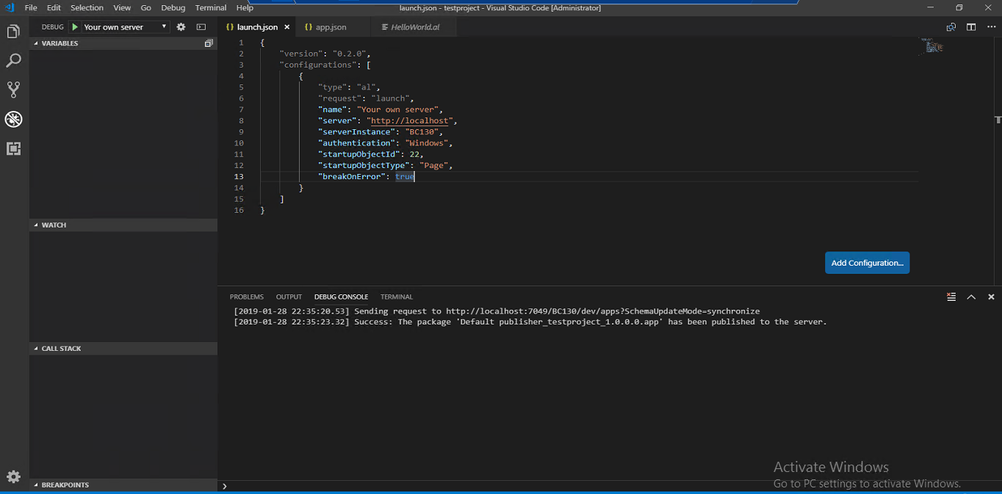

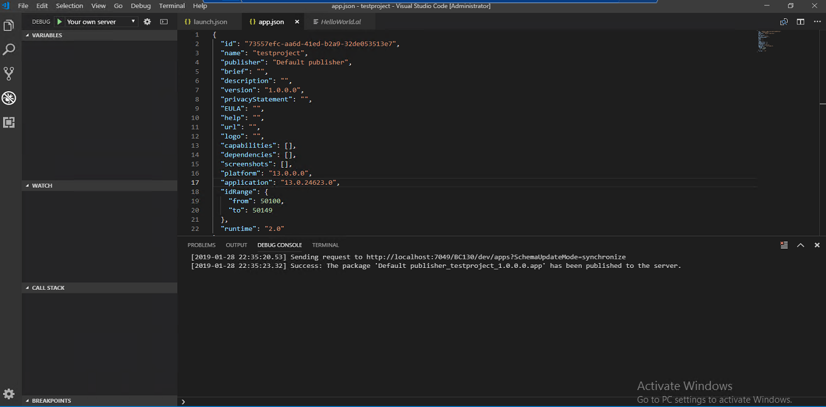

Project will always create on own server.

If getting any error clear cache then rerun command.
View-> Command Palate-> “Clear Credential Cache”

