Prerequisites

Microsoft Dynamics 365 Business Central
Visual Studio Code
Microsoft Office
- Word

Lab 1.1: Creating and Running an AL Extension
Exercise Scenario
Isaac is a developer for Cronus International Ltd. and is learning how to create objects in the development environment Visual Studio Code. He creates a new AL extension and publishes the extension to his test environment. He should see a Hello World message.
Exercise 1: Installing the AL Extension for Visual Studio Code
Exercise Scenario
Isaac installs the AL Extension.
Task 1: Start Visual Studio Code
High Level Steps
- Start Visual Studio Code from Windows.
Detailed Steps
- Start Microsoft Visual Studio Code from Windows.
  - Click Start > Visual Studio Code.
Task 2: Install the AL Extension
High Level Steps
- Go to the tab Extensions and install the AL Extension.
Detailed Steps
- Go to the tab Extensions.
  - Click View > Extensions.
  - Type “AL Language” in the “Search Extensions in the Marketplace” search box.
  - Click the green “Install” button.
  - After installation click the “Reload” button.
Exercise 2: Create a new AL Extension project
Exercise Scenario
Isaac creates a new AL Extension project with the name “Hello World” from the publisher “Cronus International Ltd”.
Task 1: Create a new AL Extension project
High Level Steps
- Create a new AL Extension project.
- Correct the settings in the launch.json file.
- Change the settings in the app.json file
Detailed Steps
- Create a new AL Extension project
  - Click View > Command Palette…
  - Type “AL: Go!” in the search box and press ENTER.
  - Ignore the authentication request by pressing ESC.
- Correct the settings in the launch.json file.
  - Click View > Explorer. The Explorer pane opens.
  - Click the folder “.vscode”.
  - Click the file “launch.json”.
  - Change the “server” setting with the URL of your Microsoft Dynamics 365 Business Central test environment.
  - Change the “serverInstance” setting with the instance name of your test environment (if needed).
- Change the settings in the app.json file
  - Click the app.json file in the Explorer pane.
  - Change the “name” setting to “Hello World”.
  - Change the “publisher” setting to “Cronus International Ltd”.
Task 2: Download the application symbols.
High Level Steps
- Download the application symbols.
- Enter your authentication credentials.
- Verify the download of the application symbols.
- Package your AL Extension.
Detailed Steps
- Download the application symbols.
  - Click View > Command Palette...
  - Type “AL: Download symbols” in the search box and press ENTER.
- Enter your authentication credentials.
  - Type your username and press ENTER.
  - Type your password and press ENTER.
- Verify the download of the application symbols.
  - Verify that you see a “.alpackages” folder with two “.app” files.
  - Verify that the “HelloWorld.al” file doesn’t show in red.
  - Open the “HelloWorld.al” file and verify that “Customer List” isn’t underlined in red.
- Package your AL Extension.
  - Click View > Command Palette…
  - Type “AL: Package” in the search box and press ENTER.
  - Verify that you see a “.app” file with the name “Cronus International Ltd_Hello World_1.0.0.0.app”.
Exercise 3: Publish the AL Extension to see the “Hello World” message box.
Exercise Scenario
Isaac publishes the AL Extension from Visual Studio Code and opens the “Customer List” to see the “Hello World” message box.
Task 1: Publish the AL Extension project
High Level Steps
- Publish the AL Extension.
Detailed Steps
- Publish the AL Extension.
  - Click View > Command Palette…
  - Type “AL: Publish”
    - The Microsoft Dynamics 365 Business Central application launches.
    - The Hello World message box appears.

Lab 2.1 Create a Table
Scenario
Simon is a developer working for CRONUS International Ltd. CRONUS
International Ltd. has decided to start selling Microsoft Dynamics 365 Business Central training courses as its business.
Simon must create a table to record course information and set several keys so that his users have the option for a different sorting sequence for the records in the table.
Objectives
The objectives are:
Show how to create a table, set basic field properties, and then create primary and secondary keys for the table.
Exercise 1: Create a Table
Exercise Scenario
Simon creates a table to store the information about courses.
Task 1: Create a Table
High Level Steps
- Start a new AL Extension project with the name “Course Mgmt” and the publisher “Cronus International Ltd”.
- Remove the HelloWorld.al file and create a table to keep the course information. This includes the course code, course name, course description, course duration in days, course type (instructor led, e-learning or remote training), course prices, and whether it is an active course or not.
- Set the OptionMembers property for the Type field.
- Set the TableRelation property for the Instructor Code field.
- Set the Primary Key field to “Code”.
- Add secondary keys for “Instructor Code” and for “Type”
- Remove the other code.
- Set the correct settings in the launch.json file to start the new table.
- Publish the table.
- Add records to the new table.
Detailed Steps
      - Start a new AL Extension project with the name “Course Mgmt” and the publisher “Cronus International Ltd”.
        - Click View > Command Palette…
        - Type “AL: Go!” in the search box and press ENTER.
        - Ignore the authentication request by pressing ESC.
        - Click View > Explorer. The Explorer pane opens.
        - Click the folder “.vscode”.
        - Click the file “launch.json”.
        - Change the “server” setting with the URL of your Microsoft Dynamics 365 Business Central test environment.
        - Change the “serverInstance” setting with the instance name of your test environment (if needed).
        - Click the app.json file in the Explorer pane.
        - Change the “name” setting to “Course Mgmt”.
        - Change the “publisher” setting to “Cronus International Ltd”.
        - Click View > Command Palette...
        - Type “AL: Download symbols” in the search box and press ENTER.
      - Remove the HelloWorld.al file and create a table to keep the course information. This includes the course code, course name, course description, course duration in days, course type (instructor led, e-learning or remote training), course prices, and whether it is an active course or not.
        - Remove the HelloWorld.al file.
        - Create a new file with the name “Course.al”.
        - Create a new table by using code snippets. Type ttable and press the TAB key.
        - Change the ID in 50100 and the name in “Course”.
        - Remove the field “MyField”.
        - Create the following fields:
Field No. | Field Name | Data Type | Length
10 | Code | Code | 10
20 | Name | Text | 30
30 | Description | Text | 50
40 | Type | Option
50 | Duration | Decimal
60 | Price | Decimal
70 | Active | Boolean
80 | Difficulty | Integer
90 | Passing Rate | Integer
100 | Instructor Code | Code | 20
      - Set the OptionMember property for the Type field.
        - OptionMember: “Instructor Led”,”e-Learning”,”Remote Training”
      - Set the TableRelation property for the Instructor Code field.
        - TableRelation: Resource WHERE (Type=CONST(Person))
      - Set the Primary Key field to “Code”.
        - Change the Primary Key “MyField” to “Code”.
      - Add secondary keys for “Instructor Code” and for “Type”
        - Add a key with the name “Secondary Key 1” for the field “Instructor Code”
        - Add a key with the name “Secondary Key 2” for the field “Type”
      - Remove the other code.
        - Remove the variable “myInt”.
        - Remove all the trigger code.
      - Set the correct settings in the launch.json file to start the new table.
        - Open the launch.json file.
        - Change the “startupObjectId” to 50100.
        - Change the “startupObjectType” to “Table”
      - Publish the table.
        - Click View > Command Palette…
        - Type “AL: Publish”
      - Add records to the new table.
        - When the Microsoft Dynamics 365 Business Central application launches create the following:
Code | Name | Description | Type | Duration | Price | Active | Difficulty | Passing Rate
80040 | Installation & Configuration | Basic knowledge of installation and configuration | Remote Training | 2 | 1,000 | Yes | 5 | 75
80041 | Finance | Basic knowledge of finance | Instructor Led | 3 | 1,500 | Yes | 7 | 80
80042 | C/SIDE Introduction | Introduction to programming | Instructor Led | 5 | 2,500 | Yes | 8 | 80
80043 | Introduction | Introduction to Microsoft Dynamics NAV | Remote Training | 2 | 1,000 | Yes | 4 | 60
80049 | Application Setup | Basic knowledge of application setup | e-Learning | 2 | 1,000 | Yes | 5 | 65
80050 | Business Intelligence | Basic knowledge of Business Intelligence | e-Learning | 1 | 500 | Yes | 5 | 65
80055 | C/SIDE Solution Development | Advanced topics in programming | Instructor Led | 5 | 2,500 | Yes | 10 | 75
        - Close the Table
Exercise 2: Create a FlowField
Exercise Scenario
Simon creates a flowfield Instructor Name.
Task 1: Create a Flowfield
High Level Steps
- Create an Instructor Name Flowfield.
Detailed Steps
- Create an Instructor Name Flowfield:
  - Open the Course.al file.
  - Add a new field Instructor Name:
    - Field No: 120
    - Field Name: Instructor Name
    - Data Type: Text
    - Length: 50
  - Set the following properties:
    - Editable: No
    - FieldClass: FlowField
    - CalcFormula: Lookup(Resource.Name WHERE (No.=FIELD(Instructor Code)))
- Publish the table.
  - Click View > Command Palette…
  - Type “AL: Publish”.
  - Close the table.

Lab 3.1 Create a Table Extension
Scenario
Simon is a developer working for CRONUS International Ltd. Simon has to create a solution to keep social media information for his customers. He must create a table extension to be able to safe social media information.
Objectives
The objectives are:
Show how to create a table extension, add extra fields.
Exercise 1: Create a Table Extension
Exercise Scenario
Simon creates a table extension to store the social media information.
Task 1: Create a Table Extension
High Level Steps
- Start a new AL Extension project with the name “Social Media” and the publisher “Cronus International Ltd”.
- Remove the HelloWorld.al file and create a table extension to keep the social media information. This includes fields for Facebook, Twitter, Instagram, LinkedIn.
- Remove the other code.
Detailed Steps
      - Start a new AL Extension project with the name “Social” and the publisher “Cronus International Ltd”.
        - Click View > Command Palette…
        - Type “AL: Go!” in the search box and press ENTER.
        - Ignore the authentication request by pressing ESC.
        - Click View > Explorer. The Explorer pane opens.
        - Click the folder “.vscode”.
        - Click the file “launch.json”.
        - Change the “server” setting with the URL of your Microsoft Dynamics 365 Business Central test environment.
        - Change the “serverInstance” setting with the instance name of your test environment (if needed).
        - Click the app.json file in the Explorer pane.
        - Change the “name” setting to “Social Media”.
        - Change the “publisher” setting to “Cronus International Ltd”.
        - Click View > Command Palette...
        - Type “AL: Download symbols” in the search box and press ENTER.
      - Remove the HelloWorld.al file and create a table extension to keep the social media information. This includes fields for Facebook, Twitter, Instagram, LinkedIn.
- Remove the HelloWorld.al file.
- Create a new file with the name “SocialMediaTableExt.al”.
- Create a new table extension by using code snippets. Type ttableext and press the TAB key.
- Change the ID in 50110 and the name in “Social Media”.
- Set the extends to “Customer”
- Create the following fields:
Field No. | Field Name | Data Type | Length
50110 | Facebook | Text | 50
50111 | Twitter | Text | 30
50112 | Instagram | Text | 50
50113 | LinkedIn | Text | 50
      - Remove the other code.
        - Remove the variable “myInt”.

Lab 4.1 Create a Card Page
Exercise 1: Create a Card page for the Course table.
Exercise Scenario
Simon wants to follow the standard recommendations for cards and lists. He first creates a card page, names it according to card page naming rules, and saves it.
Task 1: Creating a new page
High Level Steps
- Create a new Card page that has the source table Course.
- Set page properties to show the caption according to the naming conventions for card pages.
Detailed Steps
- Create a new Card page that has the source table Course.
  - Create a new file with the name “CourseCard.al”.
  - Type “tpage” and press the tab button.
  - Change the ID to 50100 and the name to “Course Card”.
  - Verify that PageType property is set to “Card” and set the SourceTable property to “Course”.
- Set page properties to show the caption according to the naming conventions for card pages and set the UsageCategory property.
  - Create the Caption property, enter “Course Card”.
  - Set the UsageCategory, enter “Documents”.
Task 2: Adding controls
High Level Steps
- Add a ContentArea container.
- Add a FastTab.
- Add the fields.
Detailed Steps
- Add a ContentArea container.
  - Verify that an area of the SubType “Content” is created in the layout section. If not, create an area of the type “Content”.
- Add a FastTab.
  - Verify that a group exists in the ContentArea, if not create a new group.
  - Change the name of the group in “General”.
  - Create the Caption property, enter “General”.
- Add the fields.
  - Add following fields in the General group
    - Code
    - Name
    - Description
    - Duration
    - Price
    - Type
    - Active
    - Instructor Code
    - Instructor Name
Task 3: Add an action to the page
High Level Steps
- Add an action to the page.
Detailed Steps
- Add an action.
  - Verify that an action is created in the actions section. If not create an action.
  - Change the name of the action "Resource Card”.
- Create the following action properties:
  - RunObject: Page “Resource Card”
  - RunPageLink: No.=FIELD(Instructor Code)
  - Image: Relationship
  - Promoted: Yes
  - PromotedCategory: Process
  - PromotedIsBig: Yes
- Remove the trigger “OnAction()”

Lab 4.2 Create a List Page
Exercise 1: Create a List page for the Course table.
Exercise Scenario
Simon now creates the list page. He follows the list page naming standards and guarantees that users cannot edit information in this page. He also makes sure that when a user double-clicks a course, the Course Card page displays the selected course. Simon also makes sure that New, Edit, and View actions work as expected in the client.
Task 1: Creating a new page
High Level Steps
- Create a new List page that has the source table Course.
- Set page properties to display the caption according to the naming conventions for list pages.
- Set page properties to specify that page type is List. Make sure that the list is not editable, and that Course Card page opens when users double-click a line in this page.
Detailed Steps
- Create a new List page that has the source table Course.
  - Create a new file with the name “CourseList.al”.
  - Type “tpage” and press the tab button.
  - Change the ID to 50101 and the name to “Course List”.
  - Set the SourceTable property to “Course”.
- Set page properties to display the caption according to the naming conventions for list pages.
  - Create the Caption property, enter “Course List”.
- Set page properties to specify that page type is List. Make sure that the list is not editable, and that Course Card page opens when users double-click a line in this page.
  - Set Editable property, enter No.
  - Set the PageType property, enter List.
  - Set CardPageID property, enter “Course Card”.
  - Set the UsageCategory, enter “Documents”.
Task 2: Adding controls
High Level Steps
- Add a ContentArea container.
- Add a Repeater.
- Add the fields.
Detailed Steps
- Add a ContentArea container.
  - Verify that an area of the SubType “Content” is created in the layout section. If not, create an area of the type “Content”.
- Add a Repeater.
  - Remove the group in the ContentArea
  - Add a Repeater with the name “General”
  - Create the Caption property, enter “General”.
- Add the fields.
  - Add following fields in the repeater
    - Code
    - Name
    - Description
- Add the fields.
  - On the View menu, click Field Menu to open the Field Menu window.
  - In the Field Menu, select the following fields:
    - Code
    - Name
    - Description
Task 3: Publish the pages
High Level Steps
- Set the correct settings in the launch.json to start the Course List.
- Publish the tables.
Detailed Steps
- Set the correct settings in the launch.json file to start the Course List.
  - Open the launch.json file.
  - Change the “startupObjectId” to 50101.
  - Change the “startupObjectType” to “Page”
- Publish the pages.
  - Click View > Command Palette…
  - Type “AL: Publish”.
  - Test your extension by adding new records.

Lab 5.1 Create a Page Extension
Exercise 1: Create a page Extension for the Social Media fields.
Exercise Scenario
Simon wants to be able to input social media information via the customer card. He first creates a page extension that will extend the customer card and saves it.
Task 1: Creating a page extension
High Level Steps
- Create a page extension that extends the Customer Card page.
- Remove the actions and variable code.
Detailed Steps
- Create a page extension that extends the Customer Card page.
  - Create a new file with the name “SocialMediaCard.al”.
  - Type “tpageext” and press the tab button.
  - Change the ID to 50110 and the name to “Social Media Card”.
  - Set the extends to “Customer Card”
- Remove the actions and variable code.
  - Remove the actions section and the variable “myInt”.
Task 2: Adding controls
High Level Steps
- Add the fields.
Detailed Steps
- Add the fields to the layout section.
  - Add following fields at the end of the General group
    - Facebook
    - Twitter
    - Instagram
    - LinkedIn
Task 3: Publish the table and page extension
High Level Steps
- Set the correct settings in the launch.json to start the Customer List.
- Publish the tables.
Detailed Steps
- Set the correct settings in the launch.json file to start the Customer List.
  - Open the launch.json file.
  - Change the “startupObjectId” to 22.
  - Change the “startupObjectType” to “Page”
- Publish the pages.
  - Click View > Command Palette…
  - Type “AL: Publish”.
  - Test your extension by opening a customer card. Your fields should appear in the “General” group.

Lab 6.1 Reading and Writing Files
Exercise Scenario
Isaac is a developer for Cronus International Ltd. and is learning how to work with files in Microsoft Dynamics 365 Business Central. He wants to be able to read and write pictures from an Item.
Exercise 1: Create a codeunit to read and write images
Task 1: Create a new AL Extension project
High Level Steps
- Create a new AL Extension project.
- Correct the settings in the launch.json file.
- Change the settings in the app.json file.
Detailed Steps
- Create a new AL Extension project
  - Click View > Command Palette…
  - Type “AL: Go!” in the search box and press ENTER.
  - Ignore the authentication request by pressing ESC.
- Correct the settings in the launch.json file.
  - Click View > Explorer. The Explorer pane opens.
  - Click the folder “.vscode”.
  - Click the file “launch.json”.
  - Change the “server” setting with the URL of your Microsoft Dynamics 365 Business Central test environment.
  - Change the “serverInstance” setting with the instance name of your test environment (if needed).
- Change the settings in the app.json file
  - Click the app.json file in the Explorer pane.
  - Change the “name” setting to “ReadingAndWritingFiles”.
  - Change the “publisher” setting to “Cronus International Ltd”.
Task 2: Create a CodeUnit
High Level Steps
- Add a new codeunit
- Create a function to import item pictures
- Create a function to export item pictures
Detailed Steps
- Add a new codeunit
  - Create a new file with the name ImageManagement.al
  - Create a codeunit with ID 50110 with the name ImageManagement
- Create a function to import item pictures
  - Create a new procedure with the name “ImportItemPicture”
  - Create a parameter Item of type Record Item
  - Create following 3 variables
PicInStream: InStream;
FromFileName: Text;
OverrideImageQst: Label 'The existing picture will be replaced. Do you want to continue?', Locked = false, MaxLength = 250;

  - Add following code to the ImportItemPicture procedure
with Item do
begin
if Picture.Count > 0 then
if not Confirm(OverrideImageQst) then
exit;

if UploadIntoStream('Import', '', 'All Files (*.*)|*.*',
FromFileName, PicInStream) then
begin
Clear(Picture);
Picture.ImportStream(PicInStream, FromFileName);
Modify(true);
end;
end;
- Create a function to export item pictures
  - Create a new procedure with the name “ExportItemPicture”
  - Create a parameter Item of type Record Item
  - Create following 4 variables
PicInStream: InStream;
Index: Integer;
TenantMedia: Record "Tenant Media";
FileName: Text;
  - Add following code to the ExportItemPicture procedure
with Item do
begin
if Picture.Count = 0 then
exit;

for Index := 1 to Picture.Count do begin
if TenantMedia.Get(Picture.Item(Index)) then begin
TenantMedia.calcfields(Content);
if TenantMedia.Content.HasValue then begin
FileName := TableCaption + '_Image' + format(Index) +
GetTenantMediaFileExtension(TenantMedia);
TenantMedia.Content.CreateInStream(PicInstream);
DownloadFromStream(PicInstream, '', '', '', FileName);
end;
end;
end;
end;
  - Create a local procedure “GetTenantMediaFileExtension”
  - Add following code
local procedure GetTenantMediaFileExtension(var TenantMedia: Record "Tenant Media"): Text;
begin
case TenantMedia."Mime Type" of
'image/jpeg' : exit('.jpg');
'image/png' : exit('.png');
'image/bmp' : exit('.bmp');
'image/gif' : exit('.gif');
'image/tiff' : exit('.tiff');
'image/wmf' : exit('.wmf');
end;
end;
xTask 3: Create a new page extension that extends “Item Card”
High Level Steps
- Create a new file, with the name ItemCardExt.al.
- Create a page extension with ID 50110 and name ItemCardExtension.
- Create 2 actions in the actions section. Actions should be added after “Functions”.
- Publish your solution and run the Item Card.
Detailed Steps
      - Create a new file, with the name ItemCardExt.al
      - Create a page extension with ID 50110 and name ItemCardExtension
      - Create 2 actions in the actions section. Actions should be added after “F&unctions”
        - Add an action ImportItemPicture
        - Set Caption to “Import Item Picture”
        - Create the OnAction trigger
        - Create a variable “ImageManagement” of type CodeUnit ImageManagement in the OnAction trigger.
        - Run the ImportItemPicture procedure from the CodeUnit variable. Pass the current record (Rec) as parameter
        - Add an action ExportItemPicture
        - Set Caption to “Export Item Picture”
        - Create the OnAction trigger
        - Create a variable “ImageManagement” of type CodeUnit ImageManagement in the OnAction trigger.
        - Run the ExportItemPicture procedure from the CodeUnit variable. Pass the current record (Rec) as parameter
      - Publish your solution and run the Item Card
        - Run the Item Card to test your solution

Lab 7.1 Create an XMLPort to Export XML Data
Scenario
Simon is a developer working for CRONUS International Ltd. Now, Simon must create an XMLPort to export all the customer information from the Customer List page in the XML format.
Objectives
The objectives are:
- Create an XMLPort.
- Extend a page to run an XMLPort.
Simon first creates the XMLPort object that imports the document.
Task 1: Create a new AL Extension project
High Level Steps
- Create a new AL Extension project.
- Correct the settings in the launch.json file.
- Change the settings in the app.json file.
Detailed Steps
- Create a new AL Extension project
  - Click View > Command Palette…
  - Type “AL: Go!” in the search box and press ENTER.
  - Ignore the authentication request by pressing ESC.
- Correct the settings in the launch.json file.
  - Click View > Explorer. The Explorer pane opens.
  - Click the folder “.vscode”.
  - Click the file “launch.json”.
  - Change the “server” setting with the URL of your Microsoft Dynamics 365 Business Central test environment.
  - Change the “serverInstance” setting with the instance name of your test environment (if needed).
- Change the settings in the app.json file
  - Click the app.json file in the Explorer pane.
  - Change the “name” setting to “Customer XML”.
  - Change the “publisher” setting to “Cronus International Ltd”.

Task 2: Create a new XMLPort
High Level Steps
- Create a new XMLPort objects and set the properties to export in XML format.
- Create an element of type Text, and name it “Root”.
- Under Root, create a child element of type Table, name it “Customer”, and set its source to 18 (Customer).
- Add attributes and child elements for Id, No., Language Code, Name, Address, Address 2, City, Post Code & Phone No.
- Remove the requestpage section.
Detailed Steps
- Create a new XMLport objects and set the properties to export in XML format.
  - Create a new AL file with the name CustXML.al
  - Use the code snippet “txmlport” to create a new XMLPort. Assign the ID 50100 and the name CustXML
  - Set the XMLPort property “Direction” to “Export” (This specifies the XMLPort to be used only for export.)
  - Set the XMLPort property “Format” to “Xml” (This specifies the external file to be an XML document.)
  - Set the XMLPort property “FormatEvaluate” to “Xml”
- Create an element of type Text, and name it “Root”.
  - Change the name of the first textelement (NodeName1) to “Root”
- Under Root, create a child element of type Table, name it “Customer”, and set its source to 18 (Customer).
  - Change the first tableelement. Change the name (NodeName2) to Customer.
  - Change the SourceTable (SourceTableName) to 18 (Customer)
- Add attributes and child elements for Id, No., Language Code, Name, Address, Addres 2, City, Post Code & Phone No.
tableelement(Customer; Customer)
{

fieldattribute(Id; Customer.Id) { }
fieldattribute(Number; Customer."No.") { }
fieldattribute(Language; Customer."Language Code") { }
fieldelement(Name; Customer.Name) { }
textelement(Address)
{
fieldelement(StreetAndNr; Customer.Address)
{
fieldattribute(Address2; customer."Address 2") { }
}
fieldelement(City; Customer.City)
{
fieldattribute(Zipcode; Customer."Post Code") { }
}
}
fieldelement(Phone; Customer."Phone No.") { }}

- Remove the requestpage section.
Task 3: Add action to the Customer List page
High Level Steps
- Add a Page Extension for the Customer List page
- Add an action container and an action.
- Set the properties to run XMLport CustXML.
- Deploy your solution.
- Run the “Export to XML” action from the page and export the customer details into a file.
Detailed Steps
- Add a Page Extension for the Customer List page
  - Create a new AL file with the name CustXMLExt.al
  - Use the code snippet “tpageext” to create a new Page Extension. Assign the ID 50100 and the name CustXMLExt
  - Extend the page “Customer List”
- Add an action.
  - Add an action to the “actions” section. Add this after the “&Customer” action
  - Give the action the name “Export to XML”
- Set the properties to run XMLport CustXML.
  - Set the RunObject property to “xmlport 50100”.
- Deploy your solution.
- Run the “Export to XML” action from the page and export the customer details into a file.
  - In the Microsoft Dynamics 365 Business Central application, open the customer list page.
  - On the Actions tab in the ribbon, click Export to XML.
  - Open or download the file, prompted via your web browser and review its contents.

Lab 7.2 Create an XMLport to Export Variable Text
Scenario
Simon is a developer working for CRONUS International Ltd. Simon has already created an XMLPort to export the customer details in XML format. Some internal systems of CRONUS International are legacy systems that cannot handle XML data. Simon must create an XMLPort to export all the customer details from the Customer List page in the comma-separated text format.
Objectives
The objectives are:
- Create an XMLPort to export data in variable text format.
- Extend a page to run an XMLPort.
Task 1: Create the XMLport
High Level Steps
- Copy XMLport CustXML as XMLport CustCSV (50101).
- Modify the properties to export data in variable text format.
Detailed Steps
- Copy XMLport CustXML as XMLport CustCSV (50101).
  - Create a new AL file with the name CustCSV.al
  - Copy the content of the file CustXML.al in the new file
  - Change the ID to 50101 and the name to CustCSV
- Modify the properties to export data in variable text format.
  - Set the Direction property to Export (This specifies the XMLport to be used only for export.)
  - Set the Format property to Variable Text (This specifies the external file to be a variable text document.)
  - Remove the FormatEvaluate property
Task 2: Add action to run the XMLport
High Level Steps
- Add an extra action to the Page Extension “CustXMLExt.al”.
- Set the properties to run XMLport Course Export Variable.
- Deploy your solution.
- Run the “Export to CSV” action from the page and export the customer details into a file.

Detailed Steps
- Add an extra action to the Page Extension “CustXMLExt.al”.
  - Add an action to the “actions” section. Add this after the “fExport To XML” action
  - Give the action the name “Export to CSV”
- Set the properties to run XMLport Course Export Variable.
  - Set the RunObject property to “xmlport 50101”.
  - Close the Properties window.
- Deploy your solution.
- Run the “Export to CSV” action from the page and export the customer details into a file.
  - In the Microsoft Dynamics 365 Business Central application, open the customer list page.
  - On the Actions tab in the ribbon, click Export to CSV.
  - Open or download the file, prompted via your web browser and review its contents

Lab 8.1 Using a Query for a Chart
Scenario
Susan, the sales order processor at CRONUS International Ltd., needs a chart that shows the top ten customers by revenue. Isaac and Simon, the consultants at the ISV Company that implements Microsoft Dynamics 365 Business Central for CRONUS International Ltd., will help Susan by creating and customizing the necessary objects, and then configure Microsoft Dynamics 365 Business Central according to Susan’s requirements.
Objectives
The objectives of this lab are:
- Learn how to create a new query.
- Understand how to set query and data item properties.
- Understand how to use totaling.
- Understand how to use a query in a chart.
Exercise 1: Creating a query
Exercise Scenario
Isaac, the business software developer, creates a new query object that selects the data that Susan wants to see in a chart part on her role center. The query will join the data from the Customer and Cust. Ledger Entries table’s, show only those customers who have ledger entries of type Invoice or Credit Memo, and display the Amount (LCY) column totaled by the Sum method.
Task 1: Create a new AL Extension project
High Level Steps
- Create a new AL Extension project.
- Correct the settings in the launch.json file.
- Change the settings in the app.json file.
Detailed Steps
- Create a new AL Extension project
  - Click View > Command Palette…
  - Type “AL: Go!” in the search box and press ENTER.
  - Ignore the authentication request by pressing ESC.
- Correct the settings in the launch.json file.
  - Click View > Explorer. The Explorer pane opens.
  - Click the folder “.vscode”.
  - Click the file “launch.json”.
  - Change the “server” setting with the URL of your Microsoft Dynamics 365 Business Central test environment.
  - Change the “serverInstance” setting with the instance name of your test environment (if needed).
- Change the settings in the app.json file
  - Click the app.json file in the Explorer pane.
  - Change the “name” setting to “Query Cust. Ledger Entries”.
  - Change the “publisher” setting to “Cronus International Ltd”.
Task 2: Create a new query object
High Level Steps
- Create a new query object.
- Select table 18, Customer as the first data item.
Detailed Steps
- Create a new query object.
  - Create a new AL file with the name CustLedgEntrQuery.al
  - Use the snippet tquery
  - Change the id in 50100 and the name in CustLedgEntrQuery
- Select table 18, Customer as the first data item.
  - Set the SourceTableName of the first dataitem to Customer
  - Set the DataItemName of the first dataitem to Customer
Task 3: Add another data item
High Level Steps
- Select table 21, Cust. Ledg. Entry as the second data item, indented under Customer.
- Set the properties for Cust_Ledger_Entry data item to link to the Customer data item, where the Customer No. field of Cust_Ledger_Entry is equal to the No. field of the Customer table, and to exclude the customers for which there are no ledger entries.
- Filter the data item to show only entries of type Invoice and Credit Memo.
Detailed Steps
- Select table 21, Cust. Ledg. Entry as the second data item, indented under Customer.
  - Create a new dataitem in the Customer dataitem.
  - Set the SourceTableName of the first dataitem to Cust. Ledg. Entry
  - Set the DataItemName of the first dataitem to CustLedgEntry
- Set the properties for Cust_Ledger_Entry dataitem to link to the Customer data item, where the Customer No. field of Cust_Ledger_Entry is equal to the No. field of the Customer table, and to exclude the customers for which there are no ledger entries.
  - Set the property DataItemLink = “Customer No.” = Customer.”No.”
  - Set the property SqlJoinType = InnerJoin
- Filter the data item to show only entries of type Invoice and Credit Memo.
  - Set the DataItemTableFIlter property = “Document Type” = filter(Invoice|”Credit Memo”)
Task 4: Add columns to the query
High Level Steps
- Add columns for the No., Name and Customer Posting Group fields to the Customer data item.
- Add a column for field Amount (LCY) to the Cust_Ledger_Entry data item.
- Specify the Sum totaling for the Amount (LCY) column.
Detailed Steps
- Add columns for the No., Name and Customer Posting Group fields to the Customer data item.
  - In the Customer Data Item, add a column for No., Give this the name “No”
  - In the Customer Data Item, add a column for Name, Give this the name “Name”
  - In the Customer Data Item, add a column for Customer Posting Group, Give this the name “CustomerPostingGroup”
- Add a column for field Amount (LCY) to the Cust_Ledger_Entry data item.
  - In the Customer Ledger Entry Data Item, add a column for Amount LCY., Give this the name “Sum_Amount_LCY”
- Specify the Sum totaling for the Amount (LCY) column.
  - Set the property Method to Sum for the Amount (LCY).
Task 5: Set query properties
High Level Steps
- Set the query properties to order the results by sum of Amount (LCY) in descending order.
- Set the query properties to return only the top 10 rows.
Detailed Steps
- Set the query properties to order the results by sum of Amount (LCY) in descending order.
  - Set the query property OrderBy = descending(Sum_Amount_LCY)
- Set the query properties to return only the top 10 rows.
  - Set the TopNumberOfRows property to 10
Exercise 2: Creating a chart
Exercise Scenario
Simon, the consultant, creates a new generic chart in Microsoft Dynamics 365 Business Central, to show the data from the query that was created by Isaac in the previous exercise. The chart will be a column chart and will show Sum_Amount_LCY as a measure that is aggregated by the Sum method over the customer number as the X-axis dimension.
Task 1: Create a new chart
High Level Steps
- Open the Microsoft Dynamics 365 Business Central Web client.
- Create a new chart.
Detailed Steps
- Open the Microsoft Dynamics 365 Business Central Web client.
- Create a new chart setup.
  - Go to the search box and type “Generic Charts.”
  - On the Home tab, in the New group, click New.
Task 2: Configure the Chart Setup Card
High Level Steps
- Set the new chart ID to 50100-01 and name it as Top 10 Cust. By Revenue.
- Set the data source of the chart to query 50100, Top 10 Cust. By Revenue.
- Define the Sum_Amount_LCY column as the measure. Set Aggregation to Sum, and Graph Type to Column.
- Define the No column as the X-Axis dimension.
Detailed Steps
- Set the new chart ID to 50100-01 and name it as Top 10 Cust. By Revenue.
  - In the Generic Chart Setup Card page, in the ID field, enter “50100-01”.
  - In the Name field, enter “Top 10 Cust. by Revenue”.
- Set the data source of the chart to query 50100, Top 10 Cust. By Revenue.
  - In the Chart Setup Card window, in the Source Type field, select Query.
  - In the Source ID field, enter “50100”.
- Define the Sum_Amount_LCY column as the measure. Set Aggregation to Sum, and Graph Type to Column.
  - On the Measures (Y-Axis) FastTab, in the Data Column field for Required Measure row, select Sum_Amount_LCY.
  - In the Aggregation field, select Sum
  - In the Graph Type field, select Column.
- Define the No column as the X-Axis dimension. a. On the Dimensions (X- and Z-Axes) FastTab, in the X-Axis field, enter “No”.
  - In the X-Axis Title field, enter “No”.
  - Click OK to close the page.
Results
A new chart setup record that shows data from query 50100, Top 10 Cust. By Revenue.

Lab 8.2 Using Queries in AL
Scenario
Julia, the marketing executive at CRONUS International Ltd., wants to be able to automatically remove any credit limits from the most valuable customers as a part of the new sales and marketing strategy. She wants the function to automatically select the top ten customers and show them in a modal list page. If the modal list page is confirmed, Julia wants it to reset the Credit Limit (LCY) field to zero for all the customers in the modal list page. She wants this function to be available from her Role Center. Isaac, the business software developer at the ISV Company that implements Microsoft Dynamics 365 Business Central for CRONUS International Ltd., will create and customize the necessary objects to meet Julia’s requirements.
Isaac, the business developer, creates a codeunit that iterates through the Top 10 Cust. by Revenue query. This codeunit populates a temporary Customer table, and then shows the Customer List page over this temporary table. When the Customer List page is closed, the confirmation dialog box is displayed. The dialog box asks whether the credit limit should be reset to zero. If the user confirms by clicking Yes, the codeunit applies the new credit limit to the selected customers.
Task 1: Create a codeunit
High Level Steps
- Create a new codeunit.
- Save the codeunit as 50101, Reset Top 10 Cust. Cred. Limit.
Detailed Steps
- Create a new codeunit.
  - Create a new AL file with the name ResetCustCredLimit.al
  - Use the snippet tquery
  - Change the id in 50101 and the name in “Reset Top 10 Cust. Cred. Limit”
Task 2: Declare variables
High Level Steps
- Declare a global variable for query 50100, Top 10 Cust. By Revenue.
- Declare a global variable for table 18, Customer.
- Declare a global variable for table 18, Customer and make it temporary.
- Declare a global text constant Text001, and set its value to “Do you want to reset the %1 to %2 for these customers?”
- Declare a global text constant Text002 and set its value to “Action completed successfully.”
Detailed Steps
- Declare a global variable for query 50100, Top 10 Cust. By Revenue.
  - Declare a new variable and set its Name to Top10Cust.
  - Set its Type to Query, and then set its Subtype to Top 10 Cust. By Revenue.
- Declare a global variable for table 18, Customer.
  - Declare a new variable and set its Name to Cust.
  - Set its Type to Record, and then set its Subtype to Customer.
- Declare a global variable for table 18, Customer and make it temporary.
  - Declare a new variable and set its Name to CustTmp.
  - Set its Type to Record, and then set its Subtype to Customer.
  - Set this variable temporary
CustTmp: Record Customer temporary
- Declare a global text constant Text001, and set its value to “Do you want to reset the %1 to %2 for these customers?”
  - Declare a new variable and set its Name to Text001.
  - Set the Type to TextConst and the value to “Do you want to reset the %1 to %2 for these customers?”
- Declare a global text constant Text002, and set its value to “Action completed successfully.”
  - Declare a new variable and set its name to Text002.
  - Set the Type to TextConst and the value to “Action completed successfully.”
Task 3: Iterate through the query
High Level Steps
- Write code that filters the Top10Cust variable to only include those rows which have Sum_Amount_LCY higher than zero.
- Write code that iterates through the Top10Cust variable.
- Write code so that each iteration cycle copies the customer information into the CustTmp temporary table.
Detailed Steps
- Write code that filters the Top10Cust variable to only include those rows which have Sum_Amount_LCY higher than zero.
  - Write the following code to the OnRun trigger:
Top10Cust.SETFILTER(Sum_Amount_LCY,'>%1',0);
- Write code that iterates through the Top10Cust variable.
  - Add the following code to the OnRun trigger:
Top10Cust.OPEN;
WHILE Top10Cust.READ DO BEGIN
END;
Top10Cust.CLOSE;
- Write code so that each iteration cycle copies the customer information into the CustTmp temporary table.
  - Enter the following code to the BEGIN/END block of the iteration.
Cust.GET(Top10Cust.No);
CustTmp := Cust;
CustTmp.INSERT;
Task 4: Apply the business rule
High Level Steps
- Add a function that resets the credit limit for all customers in the CustTmp temporary variable, and then displays the Text002 as an information message. Set the function name to ResetCreditLimit.
- Add a function that asks for a confirmation by showing the text constant Text001. If it is confirmed, it runs the ResetCreditLimit function. Set the function name to ConfirmReset.
- Show the top ten customer list as a modal page. If the user clicks OK in the page, run the ConfirmReset function.
Detailed Steps
- Add a function that resets the credit limit for all customers in the CustTmp temporary variable, and then displays the Text002 as an information message. Set the function name to ResetCreditLimit.
  - Declare a new function named ResetCreditLimit.
  - Enter the following code in the ResetCreditLimit function trigger.
IF CustTmp.FINDSET THEN
REPEAT
Cust.GET(CustTmp."No.");
Cust."Credit Limit (LCY)" := 0;
Cust.MODIFY;
UNTIL CustTmp.NEXT = 0;
MESSAGE(Text002);
- Add a function that asks for a confirmation by showing the text constant Text001. If it is confirmed, it runs the ResetCreditLimit function. Set the function name to ConfirmReset.
  - Declare a new function named ConfirmReset.
  - Enter the following code in the ConfirmReset function trigger.
IF CONFIRM(Text001,
FALSE,
Cust.FIELDCAPTION("Credit Limit (LCY)"),0)
THEN
ResetCreditLimit;
- Show the top ten customer list as a modal page. If the user clicks OK in the page, run the ConfirmReset function.
  - Append the following code to the end of the OnRun trigger.
IF PAGE.RUNMODAL(PAGE::"Customer List",CustTmp) = ACTION::LookupOK THEN
ConfirmReset;
Task 5: Test the codeunit
High Level Steps
- Create a blank page.
- Run the codeunit to verify its functionality.
Detailed Steps
- Create a blank page
  - Add a new file with name ResetCustCredLimitPage.al
  - Use the code snippet tpage
  - Set the ID to 50102 and the name to ResetCustCredLimitPage
  - Set the PageType to Card
  - Remove the SourceTable property
  - Remove the layout section and actions section
  - Remove the global variable
- Run the codeunit to verify its functionality.
  - Create the OnOpenPage trigger
  - Create a variable of Type codeunit and subtype 50101. Give the variable the name ResetCodeUnit.
  - In the OnOpenPage trigger call the Run trigger from the ResetCodeUnit variable.
  - Run the page to test the codeunit.

Lab 9.1 Creating a Basic Report
  - Scenario
Simon is a developer working for CRONUS International Ltd. CRONUS International. Simon is asked to create a report to list all customers. This report must have a RDLC and Word Layout.
Exercise 1: Build the report.
Exercise Scenario
Create a report that has the following requirements:
- Create this report with these information:
  - Prints all Customer information.
  - Create RDLC report layout
  - Create Word report layout
Task 1: Create an extension for the Customer List.
High Level Steps
- Create the page extension.
Detailed Steps
- Create the page extension.
  - In Visual Studio Code, add a new file, with the name MyCustomerListExtension.al
  - Create an extension for the Customer List, using the following code:
pageextension 50123 MyExtension extends "Customer List"
{
trigger OnOpenPage();
begin
report.Run(Report::LAB_CustomerList);
end;
}
Task 2: Create a new report.
High Level Steps
- Create the dataset.
Detailed Steps
- Create the dataset.
  - In Visual Studio Code, add a new file with the name: LAB_CustomerList.al
  - Create the dataset for the report, using the following code:
report 50105 LAB_CustomerList
{
CaptionML = ENU = 'LAB_CustomerList';
RDLCLayout = 'layouts/LAB_CustomerList.rdl';
WordLayout = 'layouts/LAB_CustomerList.docx';

PreviewMode = Normal;
WordMergeDataItem = Customer;

dataset
{
dataitem(Customer; Customer)
{
DataItemTableView = SORTING(Name);

column(No; "No.")
{
IncludeCaption = true;
}
column(Name; Name)
{
IncludeCaption = true;
}
column(Balance; "Balance (LCY)")
{
IncludeCaption = true;
}
}
}
}
  - Add a subfolder named layouts in the project
  - Build the report, using Ctrl+Shift+B, this will generate the RDLC and WORD layouts:
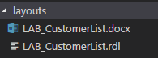
Task 3: Create a RDLC Layout
High Level Steps
- Create a layout for the report.
Detailed Steps
- Create a layout for the report.
  - Right Click the LAB_CustomerList.rdl file and select: Open Externally
  - Report Builder now opens:
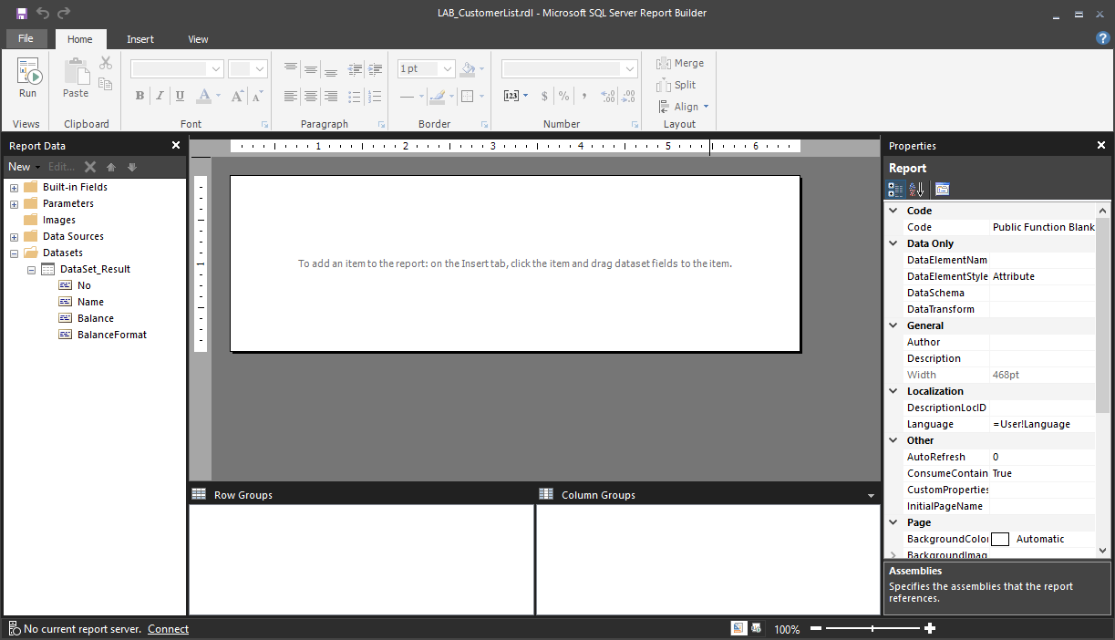
  - In the Insert menu, select Table, Table Wizard:
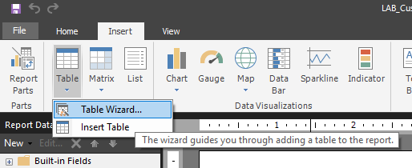
  - In the New Table or Matrix window, select DataSet_Result and click Next
  - Drag the No, Name and Balance fields onto the Values section:
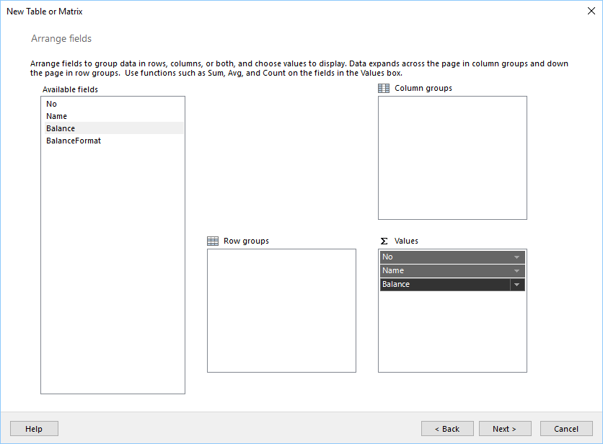
  - Click Next
  - Click Next
  - Click Finish
  - Select the Name Column and make it wider
  - Select the first row and align the content to the left
  - Save and Close Report Builder
Task 4: Create a Word Layout
High Level Steps
- Create a layout for the report.
Detailed Steps
- Create a layout for the report.
  - Right Click the LAB_CustomerList.docx file and select: Open Externally
  - Word now opens:
  - Create Table in Word with two rows and three columns:
    - On tab Insert, click on Table
    - Choose two rows and three columns
  - In the ribbon right click and select Customize the Ribbon
    - In the column on the right, enable Developer
    - Click OK
  - On Developer tab in the ribbon, click on XML Mapping Pane.
  - On Custom XML Part, choose: urn:microsoft-dynamics-nav/reports/LAB_CustomerList/50105/
  - Expand Customer
  - On the first row, type No, Name, Balance in the first, second and third column:
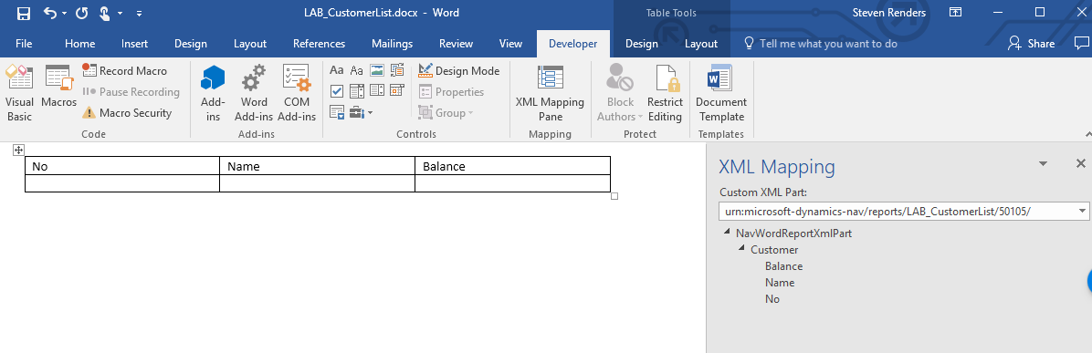
  - Mark the second row.
  - Right-click on Customer; choose Insert Content Control > Repeating.
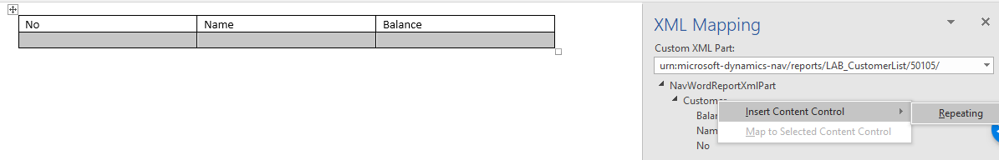
  - Set the following DataSet Result fields using right-click in customer field and Insert Content Control > Plain Text in the appropriate columns of the second row of the table:
    - No
    - Name
    - Balance
  - Close Word document and click Save.
  - You can now deploy and run the extension to see the report:
  - 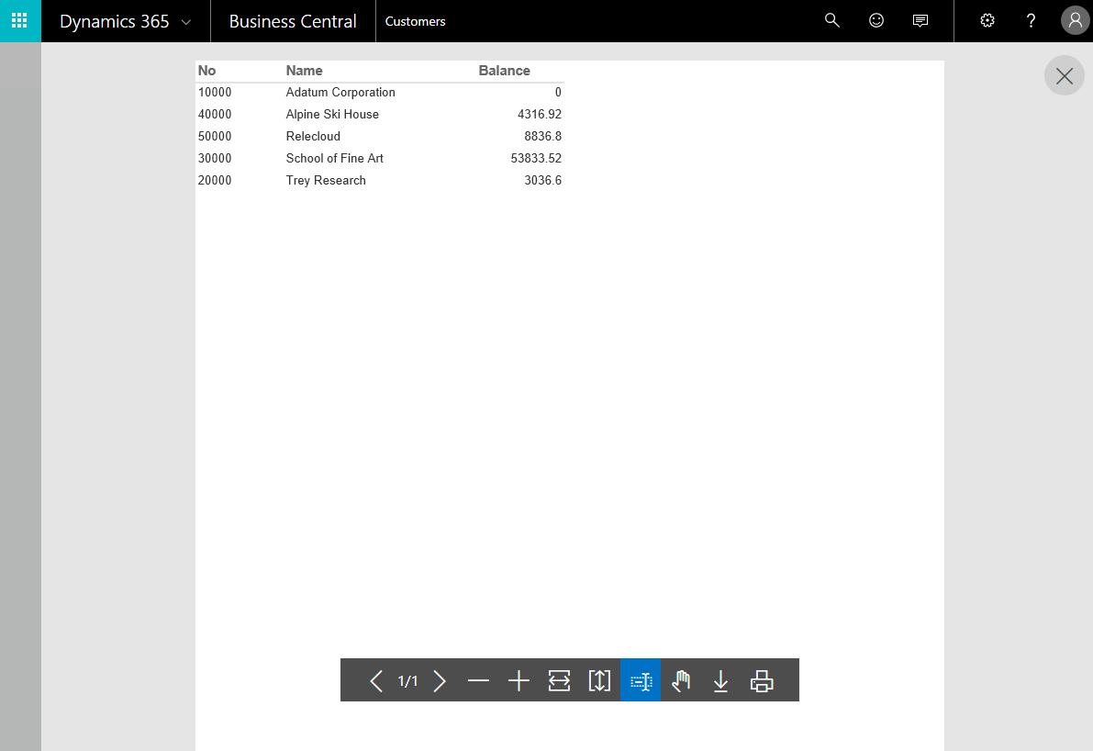
  - 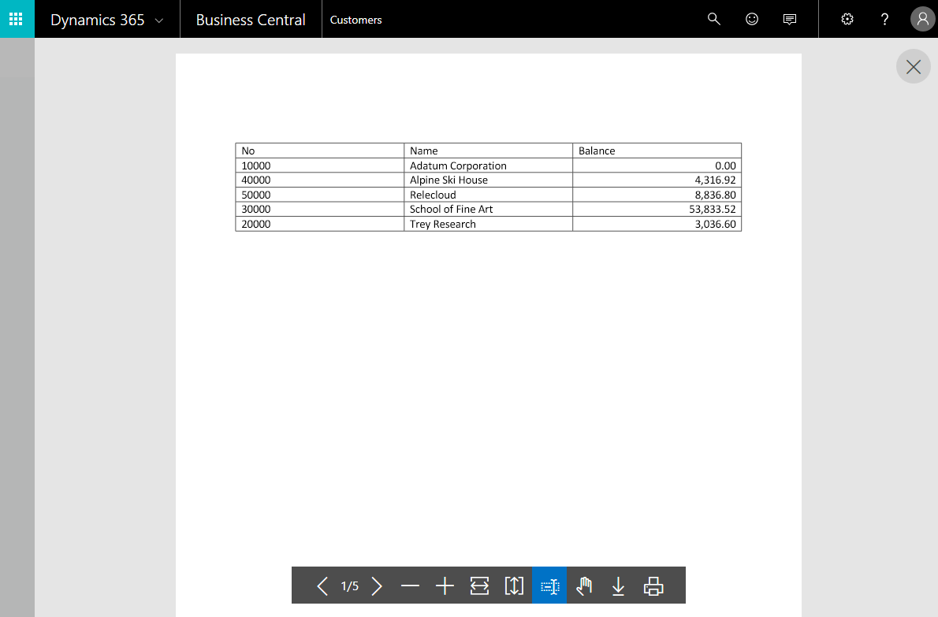

Lab 9.2 Creating a Processing Only Report
  - Scenario
Simon will create a non-printing report that enable a user to adjust the Name 2 field in the customer table. The user enters the name by which to adjust the field on the request page. The user can use the filters on the request page to filter the data and apply the adjustment to only the filtered data.
Task 1: Defining the Data Model
High Level Steps
- Define the Data Model
Detailed Steps
- To Define the Data Model:
  - In Visual Studio Code, add e new file to the project and name it ProcessingOnly.al
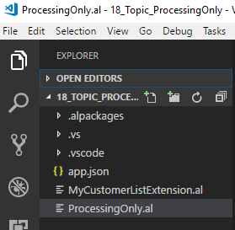
  - Use the treport snippet to create the report dataset:
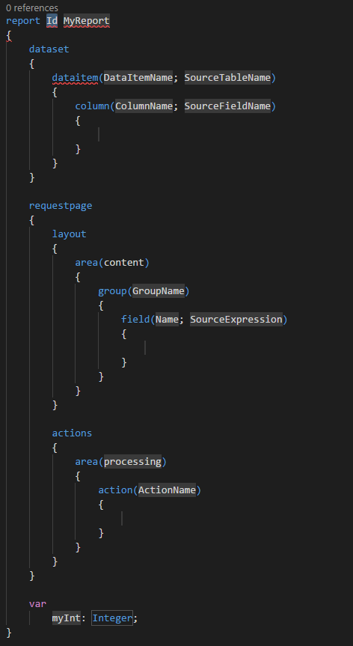
  - In the var section declare the following variables:
Name2ToApply : Text;
Customer2 : Record Customer;
ReplaceExisting : Boolean;
Counter : Integer;
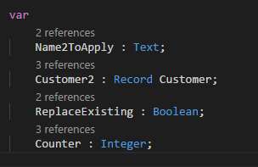
  - In the dataset section, declare a dataitem for the Customer table:
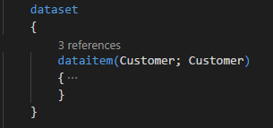
  - In the Customer dataitem add an OnPreDataItem trigger with the following code:
trigger OnPreDataItem();
begin
clear(Customer);
clear(Counter);
if not ReplaceExisting then
Customer.SetRange("Name 2",'');
end;
  - In the Customer dataitem, add an OnAfterGetRecord trigger with the following code:
trigger OnAfterGetRecord();
begin
if Customer2.get(Customer."No.") then
begin
Customer2."Name 2" := Name2ToApply;
Customer2.Modify;
Counter += 1;
end;
end;
  - In the Customer dataitem, add an OnPostDataItem trigger with the following code:
trigger OnPostDataItem();
begin
Message('Ready!, %1 Customers were updated.',Counter);
end;
  - The customer dataitem should now look as follows:
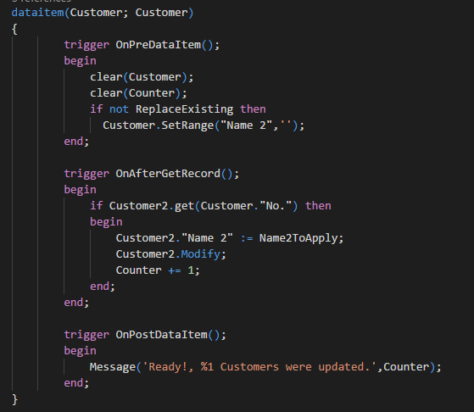
Task 2: Adding Controls to the Request Page
High Level Steps
- Adding controls to the request page
Detailed Steps
- To add controls to the request page:
  - In the requrstpage section, add the following code:
requestpage
{
SaveValues = true;

layout
{
area(content)
{
group(Options)
{
Caption = 'Options';
field(Name2ToApply;Name2ToApply)
{
ApplicationArea = All;
Caption = 'Name2ToApply';
ToolTip = 'Specifies Name2 To Apply.';
}
field(ReplaceExisting;ReplaceExisting)
{
ApplicationArea = All;
Caption = 'ReplaceExisting';
ToolTip = 'ReplaceExisting';
}
}
}
}
}
Task 3: Testing the Report
High Level Steps
- Testing the Report
Detailed Steps
- To test the report:
  - Deploy the project by pressing the F5 key:
  - The Request Page for the report displays and looks af follows:
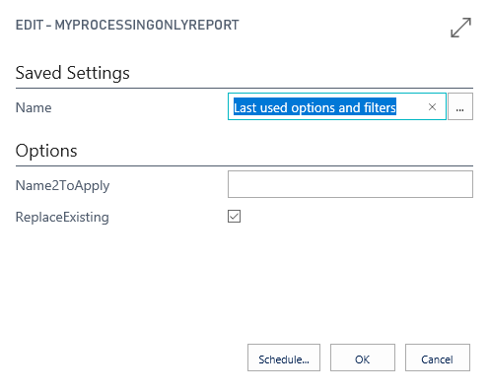
  - In the Name2ToApply field enter your name, for example Steven.
  - Select the RelaceExisting option, to make sure existing information in the Name 2 field will be overwritten.
  - Select the OK button to run the report.
  - A message appears, like for example the following:
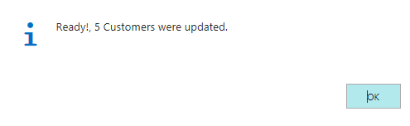
  - Select OK and Go to the Customer List page.
  - The Name 2 field should now contain the name you entered in the request page:
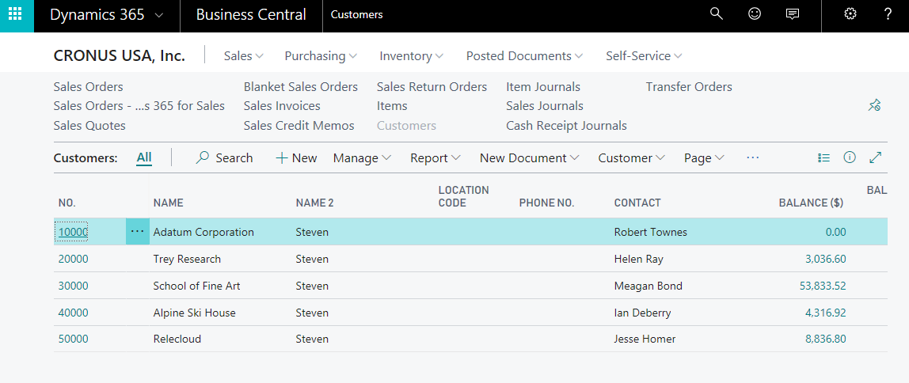

Lab 10.1 Use Microsoft Dynamics 365 Business Central as a Power BI Data Source
  - Exercise Scenario
Isaac is a Business Intelligence developer for Cronus International Ltd. Isaac would like to use Power BI Desktop and connect it to Microsoft Dynamics 365 Business Central to use it as a data source.
  - High Level Steps
- Download and install Power BI Desktop
- Add Microsoft Dynamics 365 Business Central as a data source in Power BI Desktop
  - Detailed Steps
- Download and install Power BI Desktop
  - Open your browser and navigate to: https://powerbi.microsoft.com/en-us/desktop/
  - On the Power BI website, click the download button.
  - Wait for the download to finish and then install the Power BI Desktop software.
- Add Microsoft Dynamics 365 Business Central as a data source in Power BI Desktop
  - In Power BI Desktop, in the left navigation pane, click Get Data.
  - In the Get Data window, click Online Services, click Microsoft Dynamics 365 Business Central, and then click the Connect button.
  - Power BI displays a wizard that will guide you through the connection process. The first step will be to enter an OData URL and the company name that is associated with your Dynamics 365 Financials account.
  - For the OData URL, you can copy the OData V4 URL of any of the web services that are listed in the Web Services page in Microsoft Dynamics 365 Business Central, such as https://mycompany.financials.dynamics.com:7048/MS/ODataV4/.
  - As company name, use the name that is shown in the Name field in the Company Information window in Microsoft Dynamics 365 Business Central. If your Microsoft Dynamics 365 Business Central contains multiple companies, choose the relevant company name from the list in the Companies window. In both cases, make sure that the name that you specify in the Power BI wizard matches exactly the text shown in Microsoft Dynamics 365 Business Central, such as “My Company”.
  - Once you have entered the information, click OK.
  - Note: If there are other authentication options available in the left-hand navigation, choose Basic.
  - Enter your username and password. You can find this information in the Users window in Microsoft Dynamics 365 Business Central. Use the web access key as your password. (For example, your username is ADMIN, and the web service access key that serves as your password is: EgzeUFQ9Uv0o5O0lUMyqCzo1ueUW9yRF3SsLU=.)
  - Click the Connection button to continue. The Power BI wizard shows a list of Microsoft Dynamics 365 Business Central data sources. These data source represent all the web services that you have published from your Financials.
  - Alternatively, create a new web service URL in Microsoft Dynamics 365 Business Central by using the Create Data Set action in the Web Services page, using the Set Up Reporting Assisted Setup guide, or by choosing the Edit in Excel action in any lists.
  - Specify the data you want to add to your data model, and then click the Load button.
  - Repeat the previous steps to add additional Microsoft Dynamics 365 Business Central data to your Power BI data model.
  - Once you have successfully connected to Microsoft Dynamics 365 Business Central, you will not be prompted again for the OData URL, username, or password.
  - Once the data is loaded it will appear in the right navigation on the page. At this point, you have successfully connected to your Dynamics 365 data and are ready to begin building your Power BI report.

